Online supplement
Influence of respiratory variables on the on-line detection of exhaled trace gases by PTR-MS

Methodology
Breath gas analysis techniques
Detailed descriptions of the PTR-MS gas analysis techniques are published elsewhere [Lindinger, W., A. Hansel, and A. Jordan, Int. J. Mass Spectrom, 1998. 173: p. 191-241.]. Briefly, the on-line analysis of breath samples requires subjects to exhale, via a disposable mouthpiece, into the instruments entry port. As ambient air is displaced breath is sampled at a known flow rate into the instrument via a heated sample capillary. Hydronium (H₃O⁺) precursor ions generated within the instrument are permitted to react with trace gases present within samples. The characteristic product ions formed from these reactions are subsequently detected by a downstream analytical mass spectrometer. By exploiting this fundamental approach PTR-MS is capable of the on-line and real time analysis of a range of trace gases within a single exhalation. In order to quantify the levels of trace gases within a sample the PTR-MS instrument must be calibrated against known standards. The high precursor ion count rate that is observed within PTR-MS instruments, ensures that this technique is more sensitive than other similar analytical methods, such as selected ion flow tube-mass spectrometry (SIFT-MS) [ Smith, D. and P. Spanel, Analyst, 2007. 132(5): p. 390-6.].

Quantification of trace gases by PTR-MS was achieved indirectly through comparison of product ion count rates for different breath experiments or where possible by correlating recorded product ion count rates with those determined from calibration experiments using accurately known gas standards. Calibration experiments were performed using a specifically designed gas calibration unit (Ionimed, Innsbruck, Austria) which utilises a dynamic gas dilution system to provide variable but known quantities of a range of standard compounds in a carrier gas stream trace gases.

Calibration plots for acetone, ethanol and isoprene are provided in Figure S1. For each gas the relationship between standard concentration and product ion count rate demonstrated a good linear fit, although for ethanol (m/z 47) measurements did appear more sensitive to noise. For those compounds for which calibration experiments were not performed, their levels are expressed as normalised count per second.

On-line sampling manifold
On-line monitoring of multiple selected exhaled trace gases in addition to respiratory pressures and flows was achieved by integration of the PTR-MS (IONIMED Analytik GmbH, Innsbruck, Austria) instrument with an independent LR2500 multiple-gas analyser (Logan Research Ltd, Rochester, UK). Use of the LR2500 allowed simultaneous measurement of carbon dioxide (CO₂), NO, as well as allowing regulation of expiratory pressures and flows. A schematic representation of the experimental manifold is illustrated in Figure S2. Breath metabolites investigated in the present study were as follows: methanol, acetaldehyde, ethanol, acetone, isoprene, acetonitrile, propanol, dimethyl sulphide and butyric acid. The decision to investigate these metabolites was based on a number of important factors including: (i) their prominence within exhaled breath, (ii) existing knowledge of their origins within the breath, and (iii) their association with both normal and abnormal human physiology and environmental exposures.

Healthy human volunteer subjects
The sample group of 10 healthy subjects (6 male; 4 female) enrolled in the current study had the following (mean ± standard deviation) characteristics: age 29 ± 7 yrs and body mass index 23.8 ± 4. Details of subject characteristics are provided in Table S1. All subjects were non-smokers and had been fasted for a minimum of 1 hour prior to breath sampling.

On-line respiratory manoeuvres
Breath samples were collected by asking subjects to inhale deeply, close to total lung capacity, and to then promptly provide a complete exhalation into the sampling manifold, whilst maintaining a mouth pressure >5cmH₂O. The influence of expiratory flow rate was determined by asking subjects to exhale into the manifold over a range of expiratory flows; 50, 100 and 250ml/s. Subjects were also asked to perform two further independent respiratory manoeuvres, breathold (30 second) and paced hyperventilation (30 second), each immediately before exhaling into the manifold. Hyperventilation was achieved by asking subjects to breathe at vital capacity at a rate of 10 breaths-per-minute; verbally paced by the investigator aided by an electronic metronome device (Korg MA-30, Korg, Milton Keynes, UK). For exhalations performed following breathold and hyperventilation a flow rate of 50ml/s was selected. The order in which subjects performed each of the 5 manoeuvres was assigned randomly, by means of drawing lots, and each manoeuvre was spaced by a period of 2 minutes tidal breathing at rest.

Statistical analysis
Statistical analysis was performed using the SPSS 18.0 software package (SPSS Inc., Chicago, USA.). Trace gas concentrations (not normally distributed) are presented as median values with their associated interquartile range (IQR). Statistical differences between trace gas concentrations measured at different expiratory flows were assessed using the Friedman repeated measures analysis, whilst the Sign test was used for all other pair-wise comparisons. The level of statistical significance was assigned to P-values ≤0.05.

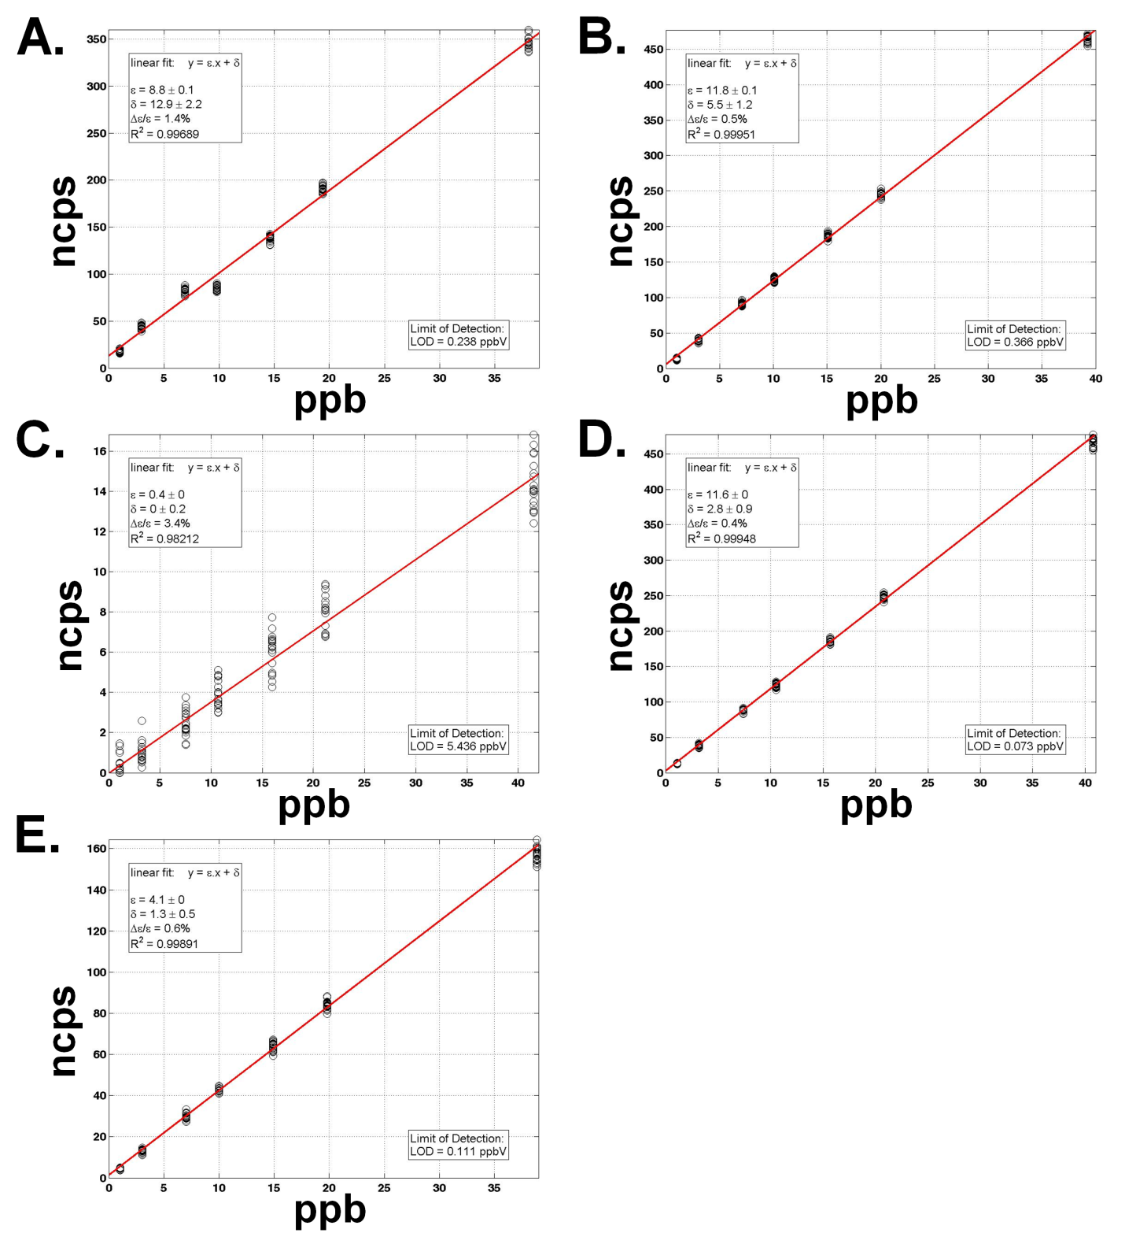
Figure S1. Calibration plots for on-line analysis of PTR-MS (A) methanol, (B) acetaldehyde, (C) ethanol, (D) acetone, and (E) isoprene by PTR-MS. (ncps, normalised counts per second)

Figure S2. Schematic representation of the breath sampling manifold. Subjects exhaled into the manifold via a disposable plastic mouthpiece. Exhaled breath was initially sampled via a calibrated heated sample capillary into the PTR-MS instrument. Beyond the PTR-MS entry port exhaled breath was directed into the manifold of a LR2500 multiple-gas analyser which sampled the breath stream for NO and CO₂ gas analysis. Subsequent sample lines monitored mouth pressure and expiratory flow. A custom-made addition to the manifold contained three precision-machined flow restrictors in parallel: clamps applied to compressible plastic tubing within the three expiratory limbs enabled effective and rapid interchange between expiratory flow rates.

Table S1. Subject characteristics
Subject Number | Gender | Age (years) | Height (cm) | Weight (Kg) | BMI
1 | M | 24 | 179 | 83 | 25.9
2 | M | 32 | 180 | 75 | 23.1
3 | M | 45 | 175 | 85 | 27.8
4 | F | 28 | 177 | 66 | 21.1
5 | F | 24 | 153 | 53 | 22.6
6 | F | 24 | 170 | 88 | 30.4
7 | M | 31 | 175 | 64 | 20.9
8 | M | 35 | 180 | 85 | 26.2
9 | M | 25 | 183 | 78 | 23.3
10 | F | 22 | 172 | 50 | 16.9
Mean ± SD |  | 29 ± 7 | 174 ± 9 | 72.7 ± 14 | 23.8 ± 4
M, male; F, female; BMI, body mass index; SD, standard deviation

Table S2. Median concentrations of selected traces gases measured in the exhaled breath of healthy volunteers after different respiratory manoeuvres
 | Instrument | Product ion (m/z) |  | 50 ml/s |  | 100 ml/s |  | 250 ml/s |  | Hyperventilation (30s) |  | Breathold (30s) |  | P
 |  |  | Units | Median | IQR | Median | IQR | Median | IQR | Median | IQR | Median | IQR
Methanol | PTR-MS | 33 | ppb | 206 | [175, 228] | 215 | [187, 228] | 219 | [163, 226] | 179 | [147, 189] | 217 | [182, 235] | ^{2,3}
Acetaldehyde | PTR-MS | 45 | ppb | 26 | [25, 28] | 27 | [25, 29] | 25 | [22, 27] | 22 | [21, 24] | 25 | [24, 27] | ²
Ethanol | PTR-MS | 47 | ppb | 410 | [366, 486] | 447 | [302, 527] | 314 | [274, 547] | 208 | [176, 277] | 420 | [327, 510] | ²
Acetone | PTR-MS | 59 | ppb | 805 | [618, 947] | 838 | [635, 913] | 898 | [730, 947] | 806 | [600, 944] | 869 | [680, 1040] | ^{1,3}
Isoprene | PTR-MS | 69 | ppb | 348 | [204, 473] | 314 | [204, 402] | 343 | [234, 412] | 357 | [278, 429] | 390 | [257, 553] | ³
Acetonitrile | PTR-MS | 42 | ncps | 35 | [32, 40] | 32 | [29, 40] | 34 | [31, 41] | 32 | [32, 43] | 37 | [29, 38]
Propanol | PTR-MS | 61 | ncps | 172 | [110-296] | 217 | [120, 453] | 201 | [107, 247] | 178 | [91, 264] | 162 | [85, 366]
Dimethyl sulfide | PTR-MS | 63 | ncps | 113 | [103, 142] | 115 | [102, 136] | 112 | [94, 131] | 103 | [114, 155] | 136 | [84, 122] | ^{2,3}
Butyric acid | PTR-MS | 89 | ncps | 70 | [40, 98] | 70 | [39, 102] | 53 | [31, 93] | 63 | [38, 109] | 71 | [31, 88]
Nitric oxide | LR-2500 |  | ppb | 8.4 | [6.3-14.7] | 7.7 | [5.6-13.4] | 6.1 | [4.6-9.0] | 8.6 | [5.7-13.8] | 8.5 | [6.8-15.2] | ¹
Carbon dioxide | LR-2500 |  | ppb | 5.5 | [5.2-5.8] | 5.4 | [5.1-5.8] | 5.4 | [5.2-5.6] | 4.5 | [4.3-5.0] | 5.9 | [5.7-6.1] | ^{2,3}
IQR, interquartile range. m/z, mass-to-charage ratio. ppb, parts-per-billion. ¹Flow rate (Freidman test) p<0.05. ²50ml/s vs. hyperventilation (Sign test) p<0.05. ³ 50ml/s vs. breathold (Sign test) p<0.05

